3GPP TSG RAN WG1 Meeting #125 R1-2604382
Dalian, China, May. 18th ~ 22th, 2026

Title: ISAC waveform and frame structure
Source: ZTE Corporation, Sanechips
Agenda item: 10.8.3
Document for: Discussion and decision

Introduction
In RAN#108，the 6G SID “New SID: Study on 6G Radio” was approved, regarding sensing are one of the key objectives as follows[1].
- Sensing – Studies to be based on use cases and associated requirements, as defined in [TR38.914]
- PHY functions and procedures for sensing technology (e.g., waveform. reference signals, measurement feedback, etc…) [RAN1, RAN4]
- Evaluate sensing performance and if necessary, extend channel modelling, for the selected use cases [RAN1]
- Aspects of integration with communication services [RAN1]
In RAN1#124-bis, the following agreements are made, and enhancements on RS sequence should be discussed in 10.8.3. The enhancements further include enhanced RS sequence and dedicated RS sequence.
Agreement:
- On RS for ISAC, study at least the following aspects, considering sensing performance, resource overhead and impact to communication
  - RS for communication is reused for sensing
  - Enhanced RS for sensing, taking reuse of RS for communication as starting point
    - Note: Part of or all of the RS may be used for communication purpose, and it does not mean the final decision on whether the enhanced RS is used for communication purpose is to be made in this agenda.
  - Dedicated RS for sensing
Agreement:
- Study RE patterns of RS for sensing, considering sensing performance, resource overhead and impact to communication
- Note: enhancements on RS sequence if any will be discussed in agenda 10.8.3
In this contribution, we mainly focus on RS sequence, waveform and frame structure, e.g. design of enhanced or dedicated RS sequence, the design of new waveform, the evaluation of RS and waveform, and so on.

Sensing waveform
No matter what waveform is used, a basic issue is that weather the sensing signal is a RS or a data signal. There are many challenging issues to realize sensing over data signal, including the following aspects:
- Signal feature. Sensing RS can be designed to have a good auto-correlation and low PAPR, and both of them greatly affect the sensing performance. As a comparison, the data signal carries some modulation constellations in the frequency domain for CP-OFDM or in the time domain for DFT-s-OFDM. For CP-OFDM, the auto-correlation is good only when the modulation order is low, e.g., QPSK, BPSK, and the PAPR is high. For DFT-s-OFDM, the PAPR can be guaranteed by low-PAPR modulation like pi/2-BPSK. while those of data signal cannot be ensured as the data is viewed as randomly generated.
- Beam direction. The beam directions of sensing and communication are not the same in most cases. Communication cares more about the link from communication transmitter to the communication receiver, while the sensing cares both the path from sensing TX to the target and the path from target to sensing RX.
- Delay and reliability. As the sensing RX requires to demodulate the data signal first, the processing delay for is increased. Moreover, the demodulation failure of data signal makes the data signal cannot be used for sensing, which further brings the sensing reliability issue.
- Power control. The requirements of power control for communication and sensing are different. Communication cares more about whether the power of data signal is higher enough at the communication receiver, while the sensing cares more about the quality echo power, which makes the power control very complex. Also, for mono-static sensing, DL power control requires to be low to avoid the saturation of the sensing receiver, but it has also to be high for data transmission.
Therefore, it is not mature to use data signal as sensing signal as the overhead reduction gain is limited and the extra challenging issues are not easy to solve.
Because the exact waveform/sequence design highly rely on whether sensing signal is data or an RS, it is important to clarify the discussion is based on data or RS. For example, for PAPR reduction, if data is used for sensing, the PAPR reduction solutions listed in agenda 10.2.1 such as FDSS with/without transparent filter, FDSS with spectral extension or with spectral truncation may be reused. However, if an RS is used for sensing, PAPR reduction maybe focus on sequence design.
Based on the above analysis, we have the following proposal:
Proposal 1: For 6GR sensing waveform design, it should be first clarified that sensing signal is an RS.
Since sensing signal is a RS even when new waveform is used, it is better to use the communication hardware to generate the sensing signal, which saves the cost of ISAC aNB. Moreover, it allows the communication node to receive the sensing signal, which makes the reuse of sensing signal for communication possible. Based on that, we have the following proposal:
Proposal 2: 6GR sensing RS should be compatible with communication hardware.

Sensing RS

3.1. Seamless Coverage Motivation
Compared with non-3GPP sensing methods, e.g., radar, WiFi sensing, the unique advantage of the 6G ISAC is the capability of providing seamless coverage by utilizing the widely deployed network infrastructure. To achieve this goal, mono-static sensing is of utmost importance. The following challenges or issues should be considered for 6G waveform/signal design:
- Stricter Coverage Requirement
One major challenge in sensing waveform/signal design is the large sensing coverage required by UAV detection. In terms of coverage, aNB mono-static sensing is a crucial sensing mode due to stronger TX and RX hardware capability, better sight from a better height and larger filed of view (FoV) which requires one node to have LOS path to target. Therefore, it is crucial to ensure the coverage of the mono-static sensing, as it decides the upper bound of 6G sensing coverage. Moreover, the coverage requirement of sensing is even higher than the communication.
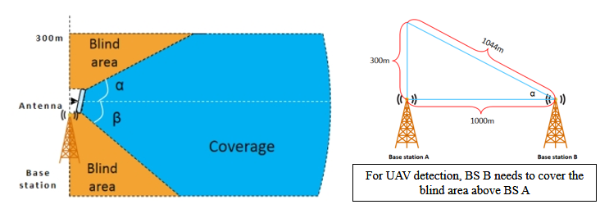
Figure 3.1-1 Blind area and coverage requirement of UAV detection and tracking
As shown in Figure 3.1-1, there is a blind sensing area on top of an aNB, and the aNB cannot detect the UAV in this area. Therefore, another aNB requires to be able to cover this area. This issue will greatly increase the sensing coverage requirement of an aNB. For example, if the inter-station distance is 1000 m, the sensing coverage requirement will be 1044 m using a conservative estimation.
Observation 1: For 6G ISAC, a coverage of larger than ISD, e.g., 1732 m in RMa, is needed due to blind area of base station, and hence a large transmission power is needed.
- Self interference and saturation
If we use the communication waveform, the aNB should support full duplex to simultaneously transmit and receive the sensing signal for mono-static sensing as shown in Figure 3.1-2. One half of antennas transmit the sensing signal, and the other half of those receive the direct-path linkage as well as the sensing echo signal. An isolator can be inserted between the transmitting and receiving antennas to increase the antenna isolation. However, even with the isolator, the receiver will still be severely saturated if the transmitting power is high, e.g. 58 dBm. According to our product test, the isolation level is around 65 dB, while the saturation level is around -30 dBm, which only allows a transmitting power of 35 dBm. Therefore, the existing RS cannot satisfy the sensing coverage requirement of UAV detection.
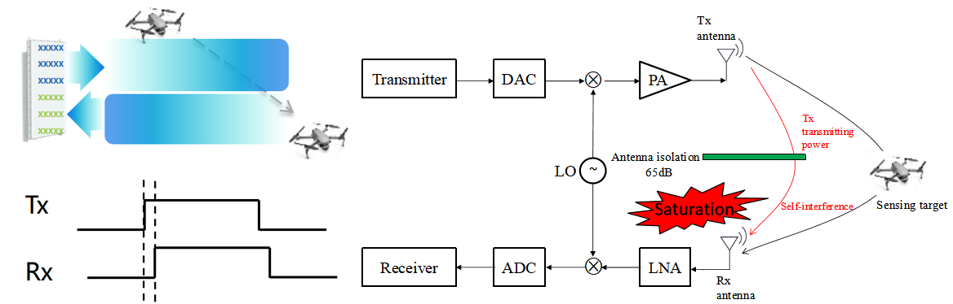
Figure 3.1-2 The issues of using existing NR waveform and RS
Observation 2: The self-interference and saturation issue greatly limit the transmission power of the communication waveform in mono-static sensing.
- TRP Mono-static Sensing as a Basis
The differences of 6 sensing modes can be categorized into the following two aspects: the node type, and the sensing mode. Both two types greatly affect the sensing performance. For the sensing node. The sensing TX or RX node can be a TRP or a UE, which obviously leads to a huge difference. The node type further leads to the following differences.
- Hardware. The hardware of TRP is much better than that of UE, and TRP can provide higher transmitting power, better receiving sensitivity and large antenna array, which are essential to the sensing performance.
- Height. The height is also very important for the sensing coverage. TRP is much higher than UE, and a much higher LOS probability can be achieved.
- Motion state. The TRP is motionless, while the UE is mobile. In UAV detection use case, it is important to assume the sensing TX and RX do not move. Otherwise, it will be very challenging to remove the static clutters, which have a much higher power than the echo power of UAV.
Whether it is mono-static or bi-static is also a crucial factor, which has the following impacts:
- Coverage. Compared with bi-static, mono-static has better sensing field of view (FoV), because the effective sensing FoV is the intersection of Tx FoV and Rx FoV. It is very difficult to use bi-static sensing to cover a large area, which also brings challenges in terms of the TRP deployment and UE selection.
- Phase synchronization. The TX node and RX node in mono-static sensing use one hardware, while those in bi-static sensing have separate hardware. As Doppler is calculated basing on the phase information of received signal, phase synchronization is required for the bi-static sensing.
- Beam overhead. As the target echo is very weak, it is important to use beam for sensing, especially for FR2. For mono-static sensing, TX and RX beams are pointing at the same direction, which means the beam scanning overhead is O(N). However, for bi-static sensing, TX and RX beams are independent, and the beam scanning overhead surges to O(N²).
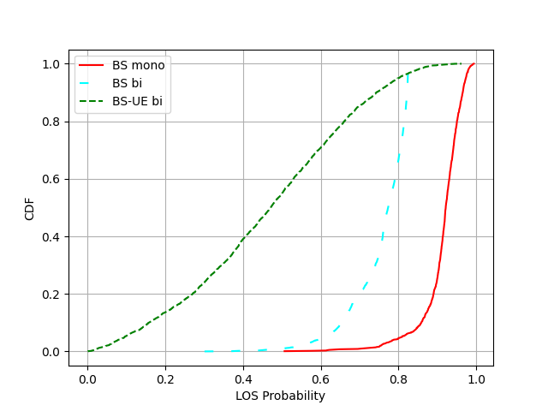
Figure 3.1-3 The CDF of Los probability for TRP mono-static sensing, TRP bi-static sensing, and TRP-UE bi-static sensing in a InF-SH AGV detection scenario

Some simulations are also done to compared the LOS probability of difference sensing modes, as shown in Figure 3.1-3. The scenario is AGV detection in InF-SH, with a TRP height of 8m and UE height of 1.5m. It can be seen that TRP mono-static sensing gains a LOS probability of 0.83@CDF=0.1, which means in 90% cases, TRP mono-static can achieve a LOS probability not less than 0.83. As a comparison, the LOS probability for TRP bi-static sensing is 0.62@CDF=0.1, while that for TRP-UE bi-static sensing is only 0.18@CDF=0.1. For this simulation, it shows that TRP-UE bi-static cannot work alone due to the insufficient sensing capability. In this case, TRP-UE bi-static sensing should not work stand-alone, and it should be a backup of TRP mono-static sensing. There is a risk for TRP-UE bi-satic sensing to satisfy the sensing requirements, and we propose to use TRP mono-static as a basic sensing mode to satisfy the sensing coverage requirement.
Observation 3: For Los probability, aNB mono-static sensing is better than aNB bi-static sensing, and aNB bi-static sensing is better that aNB-UE bi-static sensing.
Therefore, the mono-static sensing is a crucial mode, which also has the urgent requirement for new waveform and signal design. In radar signal design, the self-interference processing capability is crucial to ensure a high-performance sensing. After decades of development, the radar industry has already provided two solutions:
- Option 1: Pulse Waveform/Signal, and TX-RX switching
- Option 2: Chirp Waveform/Signal, and dechirp processing
Option 1 is simpler and can be realized without obvious changes for the hardware of communication. It has already been employed in the deployment of 5G-A ISAC due to this advantage, while Option 2 requires substantial hardware changes at both TX side and RX side.
Given that 6GR should support all six sensing modes, sensing RS/sequence specification design should consider the potential RS sharing among all sensing modes. For example, the specified sensing RS for TRP-UE bi-static mode can be also used for TRP mono-static mode.
In RAN1#124bis meeting, some candidates of sensing RS/sequence for CP-OFDM were mentioned including Pulse-like RS, FMCW-like RS, RS in guard band, sequence enhancement for Gold and ZC, etc. At the beginning of study item, we think all of those candidates should be thoroughly studied. With the considerations of other potential candidates, we have the following proposal:
Proposal 3: Study the following candidates of sensing RS/sequence for CP-OFDM, considering the potential sensing RS sharing among different sensing modes
- Pulse-like RS
- FMCW-like RS
- RS in guard band
- Sequence enhancement for Gold and ZC
- The combinations of the candidates, e.g., FMCW-based Pulse RS

3.2. Sensing RS Enhancements
The following enhancing and designing directions can be considered:
- RS-native Self-interference Processing Capability
As aforementioned, in radar signal design, the self-interference processing capability is crucial to ensure a high-performance sensing with two classical solutions in radar industry:
- Option 1: Pulse RS, and TX-RX switching
- Option 2: Chirp RS, and dechirp processing
Option 1 is simpler and can be realized without obvious changes for the hardware of communication. It has already been employed in the deployment of 5G-A ISAC due to this advantage.
Option 2 requires substantial hardware changes at both TX side and RX side. In TX, chirp signal is usually generated in the analog domain via a voltage-controlled oscillator (VCO). It is possible to generate chirp signal in the digital domain, but the effect of dechirp operation will has degradation. Moreover, in RX, the mixer of the received sensing signal and the transmitting sensing signal, instead of carrier frequency, is required, which leads to a large modification of RF front-end design.
Hence, option 1 is preferred due to the lower hardware upgrade cost. It is noted that the pulse RS generation is not new for communication, and the LP-WUS signal design or the A-IoT R2D OOK signal design in 5G can be used as a reference.
- PAPR Enhancements
As mentioned before, the communication has already considered the low PAPR issue. ZC sequence has been used, which is able to achieve constant modulus in both time and frequency domain without oversampling. However, oversampling is a must to generate a continuous-time sensing signal for transmitting. With oversampling, the PAPR and cubic metric (CM) of the ZC sequences vary a lot with different roots. As shown in Figure 3.2-1, the CM of different root indices for the ZC sequences have a maximum gap of around 3dB, which shows a great room to improve for 6G sensing. In communication, the root indices of the ZC sequence are determined with the considerations of cross-correlation between ZC sequences with different length. Especially for the small-bandwidth transmissions, the ZC sequence is very short, and the interference of a long ZC sequence depends on the cross correlation between a short ZC sequence and the truncation part of a long ZC sequence. However, for sensing, the transmission bandwidth is usually large to obtain a fair range estimation performance, and the PAPR also becomes a more dominant factor to be considered, as small echo require sufficient receiver dynamic range and saturation threshold as mentioned before. Therefore, the PAPR enhancements can be achieved with a different root indices selection strategy.
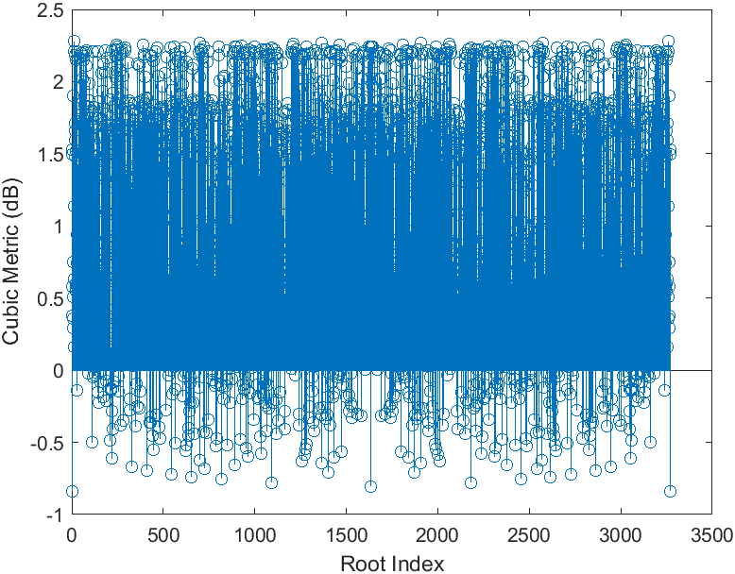
Figure 3.2-1 The cubic metric comparison of ZC sequence (length = 3271) using different root indices.
Observation 4: PAPR/CM of ZC sequences with different root indices have very large difference, e.g., ΔCM > 3dB.

- Sidelobe Reduction Capability and Flexibility
As mentioned before, the signal-native sidelobe reduction has a SNR gain over the implementation-based sidelobe reduction. For the cases when sidelobe reduction is required, a frequency-domain window can be added to the sensing RS. However, add a window to a sensing RS also changes the time domain shape. For example, a frequency-domain window is added to a ZC sequence, the time-domain counterpart after a square IDFT transformation will no longer has a constant modulus. Fortunately, this challenging problem has been solved in the radar field, and non-linear-frequency-modulation (NLFM) can be used. NLFM still have a constant modulus in the time domain, which ensures low PAPR. As the frequency sweeping is non-linear, the density of energy in the frequency domain can be controlled by the non-linear sweeping function, and equivalently the frequency domain can have non-rectangular shape. With a proper design of the non-linear sweeping function, the weighted-window shape can be obtained. Moreover, if efficient generation of NLFM can be found, the weighted window can be flexibly generated achieve a good trade-off between mainlobe width and sidelobe strength in different sensing conditions.
An example is shown in Figure 3.2-2, the time-domain modulus is constant but the frequency sweeping is non-linear, and the frequency-domain bell-like window shape can be achieved by designing the non-linear sweeping function. It can also be seen that the NLFM has 1~2dB performance gain compared with adding window only at the receiver side.
Observation 5: NLFM obtain time-domain constant modulus at sampling points as well as frequency-domain bell-like window shape.

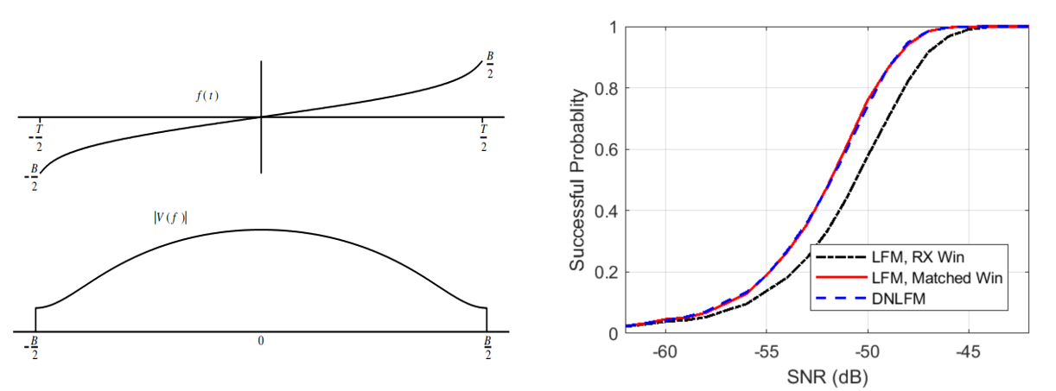
Figure 3.2-2 NLFM waveform design principle and the performance gain.
Proposal 5: Considering at least the following aspects for sensing signal enhancements:
- Self-interference mitigation at least for sensing signal sharing
- PAPR reduction
- Sidelobe reduction capability and flexibility

2.3. Pulse RS

2.3.1. The Benefits of Pulse RS
To solve the problems mentioned above, pulse RS design should be studied. Pulse RS can be used to flexibly generate a pulse sensing signal at the aNB side. The pulse sensing signal avoids the self-interference issue as the antennas are switched from transmitting to receiving after the pulse is transmitted. Therefore, the transmitting power is no longer limited by the receiver saturation. There are also some other advantages of pulse signal, e.g., all antenna elements can be used to transmit and receive, and the transmitting noise power will not propagates to the receiver. There are different methods of generating the pulse waveform/signal.
There are many benefits of the pulse RS, including:
- Ensure large sensing coverage for 6G ISAC
6G ISAC greatly relies on the aNB mono-static sensing to provide seamless coverage, and the pulse RS design can greatly improves the coverage of aNB mono-static sensing as the self-interference and receiving power saturation are avoided. Compared with existing communication RS, pulse RS can utilize the full antenna array which can use 100% of the transmission power and has higher TX beamforming gain. Furthermore, the aNB transmission power is limited by the power source driving capability, and pulse RS can have a relatively high instant TX power as the average power is not increased from the power source perspective.
- No hardware modification for mono-static sensing
Using pulse RS with TX/RX switching does not require the expensive full-duplex hardware. Even the antenna isolation is not required by pulse RS. In 5G-A implementation, pulse RS has been realized by existing communication hardware. For other non-pulse RS in mono-static sensing, not only the extra antenna isolation is required, but also the TX antennas close to the RX antennas can not be used to reduce the self interference to a reasonable range.
- Overhead reduction for multi-static sensing
Sensing requires enough resource overhead not only to accumulate the weak echo power scattered from the sensing targets but also to form a CPI to measure the velocity. In ISAC networks, the aNB mono-static sensing has sent a lot of pulse RS with high TX power, and other sensing modes can reuse this pulse RS to support a multi-static sensing without extra resource overhead. For example, an aNB can transmit a pulse RS for mono-static sensing, while another aNB or a UE can receive the same signal for bi-static sensing simultaneously. The multi-static sensing consisting of aNB mono-static sensing and aNB-UE bi-static sensing can improve the sensing performance of aNB mono-static sensing and avoid the low LOS probability with only the aNB-UE bi-static sensing.
- Measurement utilization potentially for sensing assisting communication
Pulse RS uses OFDM-based waveform, and the communication UE can receive this RS. That is to say, the sensing pulse RSs sent by aNB can be used to assist communication. The potential uses cases includes beam management, CSI measurement, or cell selection. Compared with replacing the communication RS, the pulse RS is more suitable to be used as a complementary RS to better track the channel or the beam to reduce the communication overhead or improve the communication performance.
- Equivalent to a long CP/GP length
As pulse RS usually has zeros in the tail of the CP, and the CP itself is viewed as all-zeros. Therefore, the pulse RS can be equivalent to have a long CP as all zeros before the non-zero pulse can be viewed as the CP. Also, guard period (GP) can be equivalently formed as GP requires blank period and non-zero pulse has many zeros before and after it, which can avoid the interference from the previous symbol or to the next symbol.
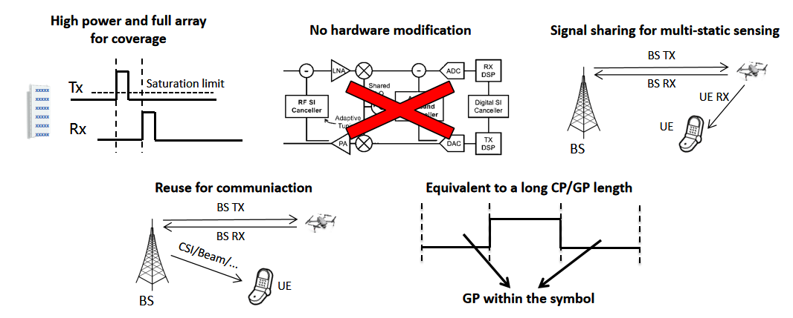
Figure 2.3.1-1 The Benefits of Pulse RS
We have the following proposal:
Proposal 6: For 6GR ISAC, study Pulse-like RS based on CP-OFDM waveform considering the following beneficial characteristics
- Large sensing coverage for 6G ISAC
- Support full duplex without hardware modification
- Overhead reduction for multi-static sensing
- Measurement utilization potentially for sensing assisting communication
- Equivalent to a long CP/GP length

With regards to whether specifying TRP mono-static sensing mode, there are two interpretations in our understanding.
In interpretation 1, aNB needs to report its sensing RS configuration to another entities, e.g. to SF or another TRP.
In interpretation 2, from the standardization perspective, the aNB mono-static sensing may not require specifying. Even when aNB mono-static sensing is not directly specified, it still has some impacts when considering sensing RS design due to sensing signal sharing with other sensing modes. The aNB mono-static sensing is the most mature way of realizing a radar function, and it usually is configured with some long-term sensing task. As a comparison, UE-invovled sensing modes is more suitable to the more instant and occasional sensing task considering the mobility of UE. Therefore, it is reasonable to share the long-term sensing RS resources of aNB mono-static sensing with other sensing modes. In this way, aNB mono-static sensing RS should be considered when specifying other sensing modes to strive to design a unified scheme for all sensing modes and reduce the overall sensing overhead.
Observation 6: With regards to specifying waveform for TRP mono-static sensing and TRP bi-static sensing, there are two interpretations:
- Alt.1 TRP needs to exchange sensing RS configuration with SF or another TRP;
- Alt.2 The sensing RS design for TRP-UE or UE-TRP bi-static sensing should consider RS sharing with TRP mono-static sensing and TRP bi-static sensing
- Note: For Alt.2, there may not be an extra spec impact on top of TRP-UE or UE-TRP bi-static sensing

Alt. 2 should be at least supported to reduce the resource overhead, as sensing requires considerable resources to accumulate weak echo signal and measure the velocity or Doppler. Furthermore, we should strive to have a unified RS design for all sensing modes. We further have the following proposal:
Proposal 7: Avoid discussion of waveform/RS per sensing mode, and strive to design a unified RS/waveform scheme for all sensing modes, i.e. the sensing RS may be shared for multi-static sensing modes.

2.3.2. The Methods of Pulse RS
There are many methods to generate the pulse RS. The most direct way is time-domain generation as pulse is a concentration of power in the time domain. Also, it can also be generated in the frequency domain, which can be realized by modified ZC sequence. Here are some examples:
- Example 1: Time-domain generation similar as pi/2 BPSK DMRS, LP-WU RS, or A-IOT OOK in NR
The generation the DFT-based pulse signal is also shown in Figure 2.3.2-1, which includes the following steps:
1. Generate a pulse using a low-PAPR sequence like LFM or ZC, and add zeros after the sequence.
2. Use the DFT to convert the sensing pulse into the frequency domain, and map the frequency-domain data to each sub-carrier.
3. Use IFFT to obtain the final time-domain pulse sensing signal.

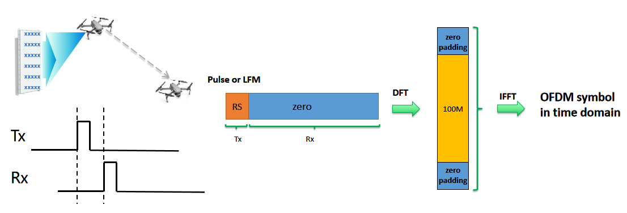
Figure 2.3.2-1 An example of generating pulse signal for sensing
- Example 2: Frequency-domain generation
The generation in the frequency domain relates to the design of pulse sequence in frequency domain. In communication, ZC sequence is also designed in the frequency domain as
For q = 1, a pulse sequence can be generated via
where 0 < β < 1 is the duty ratio of pulse sequence in the time domain.
Proposal 8: Study pulse RS sequence using at least the following generation methods:
- Time-domain generation
- Frequency-domain generation
- Other methods are not precluded
Furthermore, no matter what methods is used to generate the OFDM-based pulse RS, it can be seen as a sequence design in the frequency domain. For example, the time domain generation also obtains a frequency-domain sequence in step 2 in the above Example 1. Other nodes can receive the pulse RS without TX-RX switching, and they can view pulse RS as a new RS with a different sequence design in frequency domain.
Observation 7: For UE and other aNB nodes, the pulse sensing signal can be received and processed as an RS with a dedicated sequence in the frequency domain.

Sensing Frame Structure

4.1. The Motivation of Sensing-dedicated Frame Structure
Since frame structure has been decided in communication, the first choice of sensing is to reuse the communication frame structure if there is no strong need from sensing. In terms of frame structure, one important aspect is the CP length. The CP length issue is mainly in the mono-static sensing scenario. In communication, the CP is designed to cover the maximum delay spread, which is similar in bi-static sensing. However, in the mono-static sensing, the shortest path becomes the TX to RX self-interference link, which makes the delay spread requirement becomes an absolute delay requirement. If the round-trip delay of a target is larger than the CP length, the echo of this target will has some inter-carrier interference (ICI). The ICI issue is common-sense knowledge, but it does not mean the sensing-dedicated frame structure of longer CP is necessary.
One the one side, the impact of CP is not a hard limitation, e.g., sensing can still work in some cases when the delay is beyond the CP. On the other side, longer CP length can be supported by the following methods without changing frame structure as shown in Figure. 3.1-1:
- Frequency-domain Comb. The frequency-domain comb design is equivalent to time-domain repetitions. With the repetitions, the CP length can be viewed as extended. We can also adjust the comb size to control the equivalent comb size.
- Time-domain repetitions with continuous phase. This is a very classical method used in the RIM-RS design, which can also be used to extend the sensing CP. The difference is that for RIM-RS design, the synchronization is lost, and the aim is to receive one OFDM symbol with a 2 OFDM symbol (2OS) design, and the 2OS design can be truncated at anywhere to obtain a integral OFDM symbol. In sensing, the synchronization can be obtained, and the CP length can be extended up to M-fold, and M symbols can be received for an M OFDM symbol (MOS) RS design, M > 1 for generality. One method of generating an MOS design is to make a certain cyclic shift to the symbols which satisfies the sub-carrier phases of two symbols are continuous.
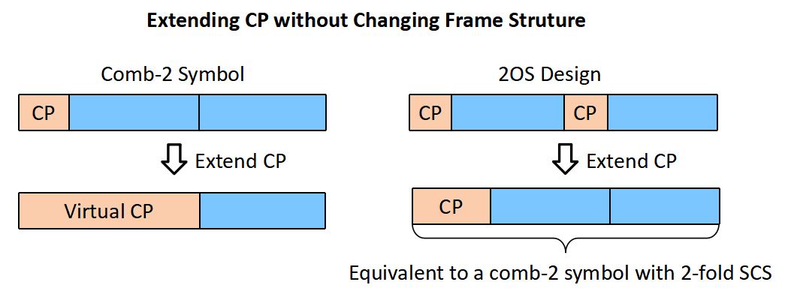
Figure. 3.1-1 The examples of extending CP without changing frame structure
We have the following proposal:
Proposal 9: When needed, CP length should be equivalently extended without changing frame structure, e.g., frequency-domain comb, time-domain repetitions with continuous phase.

4.2. Potential Enhancements of MOS Design
As shown in Figure. 3.1-1, the 2OS design can also be viewed as one OFDM symbol with a new frame structure with a half sub-carrier spacing and frequency-domain comb-2. That is to say, a new frame structure is supported without modifying the normal frame structure. For the generality, we use MOS(multiple OFDM symbols) instead of 2OS, as the number of symbols does not have to be fixed to 2 in sensing. One potential enhancement is that, as the MOS design can be viewed as comb-M symbol with M-fold SCS, it is possible to multiplex M users in the same resource.
We have the following proposal:
Proposal 10: Study NR RIM-RS like design for 6GR sensing, i.e. considering single FFT operation for one RS resource with multiple OFDM symbols.

Evaluation for Sensing Signal

5.1. General Framework
To compare the sensing signal (including both sensing RS and waveform), the most import thing is to have a final metric to determine which sensing signal is better. The general framework is similar to evaluation, and we should have a sensing net gain to determine overall performance of difference sensing signals. Sensing net gain can be calculated as follows.
Sensing Net Gain [dB] = TX power gain relative to the reference – SNR degradation relative to the reference
For sensing, the definitions of TX power gain and SNR degradation are different.
- TX power gain
TX power gain includes the impact of sensing signal PAPR on the power amplifier back-off. Apart from PAPR issues, there are also other relating factors which only occur in sensing, including power saturation issue, TX antenna number, and TX beam forming gain, etc. Obviously, this factor can be calculated using waveform analysis.
- SNR degradation
For sensing, the SNR degradation can be calculated in one of waveform analysis and LLS/SLS. For waveform analysis, it can be derived using the SNR degradation after frequency-domain division. For LLS/SLS, it should be calculated using the SNR that satisfies all sensing performance targets.
We have the following proposal:
Proposal 11: Study the sensing net gain to evaluate the overall/final performance of sensing signal using the following formula.
- Sensing Net Gain [dB] = TX power gain relative to the reference – SNR degradation relative to the reference
- TX power gain is determined by the waveform analysis
- SNR degradation is determined by
  - Option 1: Theoretical SNR degradation by waveform analysis
  - Option 2: Simulated SNR degradation by LLS/SLS

5.2. Waveform Analysis Methods
The waveform analysis includes the following metrics:
- Auto-correlation in time domain
The communication RS has constant modulus in the frequency domain, as it needs to equally estimates the channel information at difference sub-carriers. The sensing RS requires a perfect period auto-correlation in time domain. Period auto-correlation is used. Although the requirements look very different, they are equivalent, and here is proof.
Assume a time-domain sequence x_{n}, n=0, 1, …, N−1. The frequency-domain counterpart can be obtained using discrete Fourier transform (DFT) as:
$$X_{k}=\sum_{n=0}^{N−1}{x_{n}e^{−j\frac{2π}{N}kn}},k=0, 1, …, N−1.$$
Constant modulus in frequency domain means $\left|X_{k}\right|=C$ for all k. Perfect auto-correlation in time domain means the periodic auto-correlation function:
$$A(τ)=\sum_{n=0}^{N−1}{x_{n}x_{(n+τ) mod N}^{∗}},$$
which satisfies:
$$A\left(0\right)≠0,A\left(τ\right)=0 for τ( mod N)≠0,$$
One well-known property is that the DFT of the periodic auto-correlation is the power spectrum as
$$\sum_{τ=0}^{N−1}{A\left(τ\right)e^{−j\frac{2π}{N}kτ}}={\left|X_{k}\right|}^{2}$$
Then, we can derive from frequency-domain constant modulus to time-domain perfect period auto-correlation via changing the above formula in the following form as
$$A(τ)=\frac{1}{N}\sum_{n=0}^{N−1}{{\left|X_{k}\right|}^{2}e^{j\frac{2π}{N}kτ}}=\frac{C^{2}}{N}\sum_{n=0}^{N−1}{e^{j\frac{2π}{N}kτ}}$$
As $\sum_{n=0}^{N−1}{e^{j\frac{2π}{N}kτ}}=\left\{\begin{matrix}N,τ( mod N)=0 \\ 0,τ( mod N)≠0\end{matrix}\right.$, the perfect auto-correlation is achieved.
Similarly, the derivations from time-domain perfect period auto-correlation to frequency-domain constant modulus are as below:
$${\left|X_{k}\right|}^{2}=\sum_{τ=0}^{N−1}{A\left(τ\right)e^{−j\frac{2π}{N}kτ}}=A\left(0\right)e^{−j\frac{2π}{N}k∙0}=A\left(0\right)$$
Therefore, the communication and sensing RS has the equivalent requirements of constant modulus in frequency domain and perfect period auto-correlation in time domain.
With this equivalence, the performance gap to an RS with perfect period auto-correlation. In ISAC system, in order to obtain the channel information, the frequency domain division at the k-th sub-carrier is done as
$${\hat{H}}_{k}=\frac{H_{k}X_{k}+N_{k}}{X_{k}}=H_{k}+\frac{N_{k}}{X_{k}}$$
The difference is the noise in the channel estimations in terms of of whether the frequency-domain sensing signal has constant modulus, or equivalently saying, whether the time-domain period auto-correlation is perfect. As noise power can be directly added, it is easy to obtain a equalization loss (dB) compared to perfect period auto-correlation as
$$Theoretical SNR degradation =10log\left(\frac{1}{N}\sum_{k=0}^{N−1}{\frac{1}{\left|X_{k}\right|}}\right) (dB)$$
- Low Auto-correlation Sidelobes
It is important to point out that perfect period auto-correlation is only perfect for the cases when oversampling is not considered. Without oversampling, the auto-correlation impulse is only shown at the zero delay. However, with oversampling, the auto-correlation function becomes a sinc function. The sidelobes of sinc function leads to some potential issues as low detection rate for targets weaker than sidelobes of other targets and high false alarm rate of identifying sidelobes as targets. There are two options to reduce sidelobes:
- Option 1: add a weighted window to the frequency-domain channel estimations before IFFT at the receiver side
- Option 2: add a weighted window to the frequency-domain sensing signal at the transmitting side, and use frequency-domain conjugate multiplexing to obtain windowed frequency-domain channel before IFFT at the receiver side
Option 1 is much simpler and can be implemented without affecting the sensing RS design. However, the drawback is that if the weighted window is only added at the receiver side. The processing of the frequency-domain constant-modulus sensing RS is no longer a matched filter. As matched filter is able to maximize the SNR, Option 1 has some SNR losses if weighted window is required. As a comparison, Option 2 requires the weighted window to be added to the sensing signal, and in this case, the SNR can still be maximized without losses.
The perfect period auto-correlation and the low auto-correlation sidelobes are a trade-off in the receiver strategy selection. The perfect period auto-correlation gives us a narrowest mainlobe without considering sidelobes, while the low auto-correlation sidelobes inevitably.
- Low PAPR
In terms of the transmission efficiency, the PAPR requirements are similar for both communication and sensing RS. Both of them benefits from a low PAPR design, and the 6G communication has already had the following agreements.
RAN1#122-bis
Agreement
- For uplink low-PAPR proposals, the link level performance evaluation criterion is Net Gain assuming same spectrum efficiency as the reference
  - Net Gain [dB] = Tx power gain relative to the reference – SNR degradation relative to the reference @10% BLER
    - A realistic PA model should be used
    - When calculating the Tx power gain, the RAN4 metrics on the Tx power should be taken into account.
    - For SNR degradation, fading channel and non-ideal channel estimation, including DMRS configuration, and equalization is encouraged.
    - FFS: Other evaluation metrics
    - Note: Companies to report how to calculate the Tx power gain, modulation and coding
There is also something different between these two functions. Sensing benefits more from the low-PAPR RS design. The sensing receiver needs to identify weak echos together with the strong signal from interference, LOS path or large clutters, and thus the dynamic range becomes more important. For a low-PAPR RS, the receiver can allow a larger range is used for the weak signal and benefits the sensing performance. Moreover, for mono-static sensing, low-PAPR RS also makes the saturation threshold higher as it has less spikes.
- Self-interference Resilience
As mentioned before, TRP mono-static sensing plays a key role of guaranteeing the sensing coverage, and the self-interference avoidance capability should be also be taken into account. If the communication RS is still used, the transmission power cannot be high, which greatly limits the sensing performance. This issue has been identified in 5G-A under the antenna isolation assumption of 65dB. There is an optimistic option of 80dB, however it is challenging in the real deployment.
- Maximum Unambiguous Range
The maximum sensing range can be affected by many aspects, and here we only focus on the impact signal design. For signal design, there are two potential issues: CP length, and frequency domain density. For sensing signal design, the CP length cannot be changed, and the impact of CP is not a hard limitation, e.g., sensing still works when the delay is beyond the CP. As a comparison, the frequency domain density is a hard limitation. Assume the spacing of the used sub-carrier is ${∆f}_{eff}$, and the maximum unambiguous range is
$$r_{max}=\frac{c}{2{∆f}_{eff}}$$
The comb size of communication RS should be examined, and if not enhancements are required.
- Reusing for Communication
It is important to let the sensing waveform/signal to be reused for communication purpose. The major reason is that the sensing overhead cannot be neglected, as sensing requires to accumulate over time and cover multiple directions. If it is not reused for communication, the communication functionality may be affected due to less resources. It is very likely that the sensing waveform/signal may not be the best design for communication, but it is beneficial to reuse it for communication to save the overall overhead of the network and allow more communication data traffic as the sensing overhead is large and inevitable for most sensing cases.
These waveform metrics affects the sensing net gain in the following manners:
Waveform metrics | Impact on sensing net gain
1a. Constant modulus in frequency domain | Used for frequency-domain division. Affects theoretical SNR degradation
1b. Auto-correlation mainlobe and sidelobe | Used for time-domain convolution. Affects simulated SNR degradation
- PAPR issue | Affects the TX power gain
- Self-interference | Affects the TX power gain/degradation
- Maximum unambiguous range | Severe SNR degradation, e.g., sensing can not work
- Reusing for communication | No. Only affect the resource overhead.
We have the following proposal:
Proposal 12: At least the following waveform metrics should be considered for 6G sensing signal.
- Period auto-correlation
- PAPR issue
- Self-interference resilience
- Maximum unambiguous range
- Reusing for communication

5.3. LLS/SLS Methods
LLS/SLS can be used to calculate SNR degradation. Before that, the first problem is whether we need LLS/SLS as theoretical SNR degradation can also be used. If theoretical SNR degradation is not enough, the follow-up problem is that which one of the LLS or SLS should be used. We compare these three methods in table 5.3-1.
Table 5.3-1 The comparison of theoretical, LLS and SLS to calculate SNR degradation
SNR Calculation methods | Pros | Cons
Theoretical | Simplest way to measure the impact of sequence design by assuming frequency domain division is used. | May not be applicable for some time-domain convolution based sensing methods. Cannot use for
LLS | Can be a simplified version of SLS. A good trade-off between complexity and accuracy. | Requires time to develop LLS as there is no consensus in the previous 5G-A SI.
SLS | The most reliable way to verify the sensing performance of different sensing signals. | May lead to a huge simulation overhead as multiple TX power/SNR are required to calculate the SNR degradation.
We are open to these methods. For this SI, we think more time should be spent on different sensing signal designs, instead of using too much discussion on how we compare the difference sensing signals. Therefore, we have the following proposal:
Proposal 13: For SNR degradation/gap calculation, the first priority is to only use LLS, and if LLS has no consensus, SLS should be used.

5.4. Evaluation Results

5.4.1. Waveform Analysis
In this section, CSI-RS sequence, time-domain generated pulse sequence and frequency domain generate pulse sequence are compared. The sequence length is 3264, the IFFT size is 4096. The oversampling IFFT size (the number of oversampling points) for PAPR/CM calculation is 16384. Figure 5.4.1-1 shows that the time domain amplitude comparison of these sequences. It can be seen that the CSI-RS has many spikes, while TD pulse and FD pulse have more stable amplitude in the time domain.
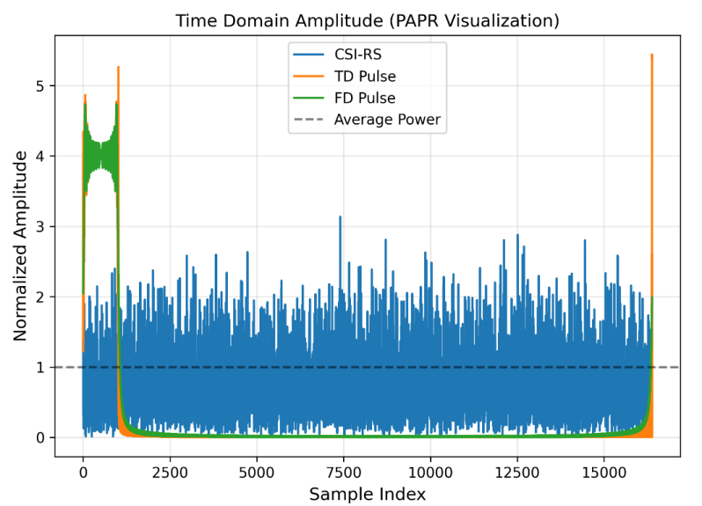
Figure 5.4.1-1 Time-domain Amplitude Comparison
The CCDF of PAPR is shown in Figure 5.4.1-2. The PAPR@1e-3 and CM value are also listed in this figure. CSI-RS suffers from high PAPR and CM, 8.32 dB and 3.31 dB. The PAPR of FD pulse, 1.52dB, is lower than that of TD power, 2.20dB, while the more accurate metric, CM, of them is very close, -0.67dB and -0.64dB.
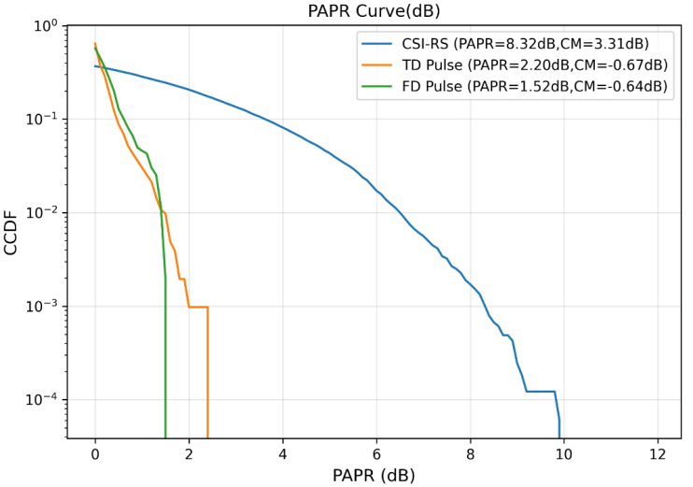
Figure 5.4.1-2 PAPR comparison with calculated PAPR@1e-3 and CM
Figure 5.4.1-3 shows frequency domain magnitude spectrum comparison of these sequences. It shows that the frequency domain shape of CSI-RS and FD pulse is flat, which represents an optimal auto-correlation of sinc function. For TD pulse, the spectrum is close to constant magnitude, and it has some small values caused by ripples.
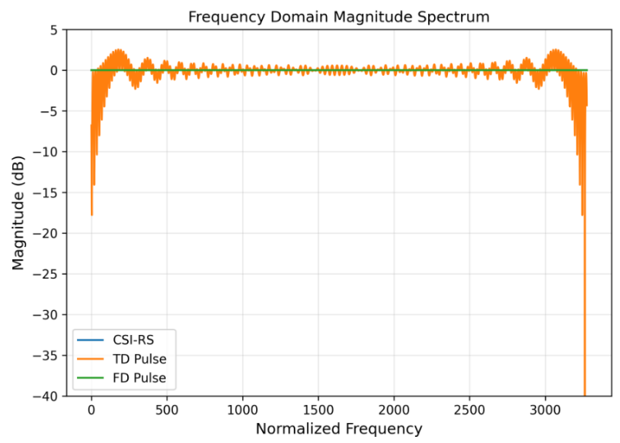
Figure 5.4.1-3 Frequency domain magnitude spectrum comparison
The cyclic auto-correlation comparison is then shown Figure 5.4.1-4. As all three sequences have a flat or almost flat spectrum, the cyclic auto-correlation shape is very close to each other. For both CSI-RS and FD pulse, the PSLR is 13.30dB, and ISLR is 9.68dB. For FD pulse, the PSLR and ISLR are 13.29 dB and 9.51 dB, which is very close to each other.
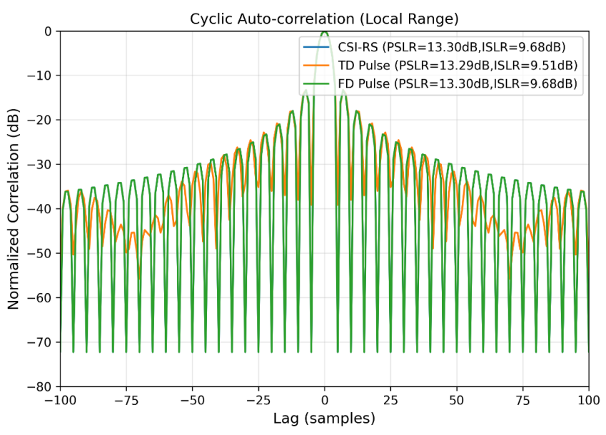
Figure 5.4.1-4 Cyclic auto-correlation comparison with calculated PSLR and ISLR
Observation 8: For time-domain pulse and frequency-domain pulse, the waveform characteristics, including PAPR/CM and auto-correlation (mainlobe and sidelobe), are very close to each other.

5.4.2. System-level Sensing Simulation
A system-level simulation of 4GHz RMa-AV aNB mono-static sensing scenario is conducted to compare the performance of without and with pulse signal. As the evaluation assumptions in agenda 10.8.1 are not ready, the simulation is based 5G-A evaluation assumptions for TRP mono-static sensing. The relating parameters are listed in Table 5.4.2-1. In this simulation, DFT-based sensing signal is used.
Table 5.4.2-1 Evaluation assumptions of CP-OFDM and pulse signal comparison
Parameters |  | Assumptions of CP-OFDM | Assumptions of pulse signal
Scenario  (different from baseline) |  | (RMa-AV,1732m)
Sensing Tx/Rx operating simultaneously or not |  | Sensing Tx/Rx operating simultaneously | Sensing Tx/Rx not operating simultaneously
Carrier frequency |  | 4GHz
Max BS Tx power  (different from baseline) |  | 37 dBm | 56 dBm
BS antenna configuration  (different from baseline) |  | Configuation A: (M, N, P, Mg, Ng, Mp, Np)  Tx: (8,8,2,1,1;4,8)  Rx: (8,8,2,1,1;4,8)  Or Configuation B: (M, N, P, Mg, Ng, Mp, Np)  Tx: (12,16,2,1,1;2,16)  Rx: (12,16,2,1,1;2,16)  $\left(d_{H},d_{V}\right)$ = (0.5, 0.8)λ, +45°/-45° polarization | Configuation A: (M, N, P, Mg, Ng, Mp, Np)  Tx/Rx: (16,8,2,1,1;8,8)  Or Configuation B: (M, N, P, Mg, Ng, Mp, Np)  Tx/Rx: (24, 16, 2, 1, 1; 4, 16)  $\left(d_{H},d_{V}\right)$ = (0.5, 0.8)λ, +45°/-45° polarization  Note: Tx antenna elements and Rx antenna elements are operating asynchronously with same antenna elements.
Number of targets per sector in the center site |  | N=5
Target vertical distribution |  | 25-300m
Waveform  (different from baseline) |  | CP-OFDM | Pulse signal generated by OFDM
System bandwidth |  | 100 MHz
Numerology |  | SCS = 30 kHz
CPI (ms) |  | 64
Period of CPI (ms) |  | 576
BS Layout |  | Hexagonal grid, 7 macro sites, 3 sectors per site.  3 sectors with 30, 150, 270 degrees
Wrap-round |  | No wrap-round
BS antenna height |  | UMa-AV: 25 m
BS antenna radiation pattern |  | Table 9 in Report ITU-R M.2412
BS antenna mechanic tilt |  | 90° in GCS (pointing to horizontal direction)
BS antenna electrical tilt |  | Option 1: no electrical tilt
Polarized antenna model |  | Model-2 in clause 7.3.2 in TR 38.901
Antenna isolation  (different from baseline) |  | 65 dB | Not applied
Inter-site interference |  | Not modelled
Self-interference  (different from baseline) |  | The residual leakage interference/noise is modelled e.g. by additional additive white Gaussian noise, -94+X dBm in 100 MHz, X=5dB | X=0dB
Co-site inter-sector interference |  | Not modelled
Adjacent channel interference |  | Not modelled
BS receiver noise figure |  | 5 dB
Sensing target | Target type | UAV with small size (0.3m x 0.4m x 0.2m)
 | 3D distribution | 5 targets per sector in the center site only  Horizontal plane: Uniformly distributed in a sector  Vertical plane: Uniformly distributed between 25m and 300m, optionally between 1.5m and 300m.
 | Mobility | Horizontal speed: uniformly distributed between 0 and 180km/h  Vertical speed: 0km/h
 | Minimum BS-target 3D distance | 10 m
 | Minimum target-target (3D) distance | 10 m
 | Outdoor/indoor proportion | 100% outdoor
 | LOS/NLOS | LOS and NLOS
 | Orientation | Random in horizontal domain
 | RCS model | RCS model 1 for UAV with small size
gNB-target link |  | TRP-UAV link in Table 7.9.3-2 in TR 38.901, using Clause B.1.3 in TR 36.777
Concatenation of TX-target and target-RX links |  | Option 2 in Step 9 in section 7.9.4.1, TR 38.901
The power threshold for path dropping after concatenation for target channel |  | -40 dB
Method for association of detected object(s) and true targets(s) |  | Based on each true target, the nearest detected object within a distance of 10 meters from the true target is regarded as an estimation of true target; otherwise, it is considered as a false alarm.
Low power cluster |  | Not modeled
Clutter mobility |  | Not modeled
TRP selection method |  | A target is present in the channel of multiple TRPs  Large scale channels and small scale channel between each target and all adjacent STX/SRXs are generated accordingly. For each sensing target, one typical STX/SRX with highest received power after whole target channel is selected.  For each selected STX/SRX, all targets in its and adjacent serving cells could be measured as selected targets or interference.
Tx beam information  (different from baseline) |  | 4 vertical beams and 2 horizontal beams  For each beam, comb 4 in frequency domain and comb 7 in time domain | 4 vertical beams and 2 horizontal beams  For each beam, comb 1 in frequency domain and comb 7 for each 2 pulse signal beam in time domain
T/F RE mapping of sensing RS, assumed TDD UL/DL configuration if applicable |  | In each CPI of 128 slots, 4 vertical beams are used, and using 2 periods of CPI to scan all beams. Each beam would occupy n-th and n+7-th (n=0,1,...3) symbol with comb-4 in each slot of CPI. | In each CPI of 128 slots, 4 beams are scanned, and using 2 periods of CPI to scan all beams of pulse signal. In each slot, every 2 beams would occupy n-th and n+7-th (n=4,5) symbol with comb-1 in each slot of CPI.
 |  | For CP-OFDM and pulse signal generated with OFDM without tracking knowledge, the sensing resource ratio is calculated by
Sensing signal/data processing method |  | RD-profile: 2D-DFT  Peak detection on RD-profile: CFAR  Angle estimation: Maximum likelihood (ML) estimation
Cooperative sensing |  | The STX/SRX selection is based on measured RD profile of each STX/SRX, and then only one best STX/SRX is decided to measure one typical sensing target.
UAV motion model |  | No
For the sensing without pulse signal, only the CP-OFDM with existing RS is used. For antenna configuration A, the CDF curves of position and velocity accuracy, missing detection probability and false alarm probability are provided based on evaluation results as below.
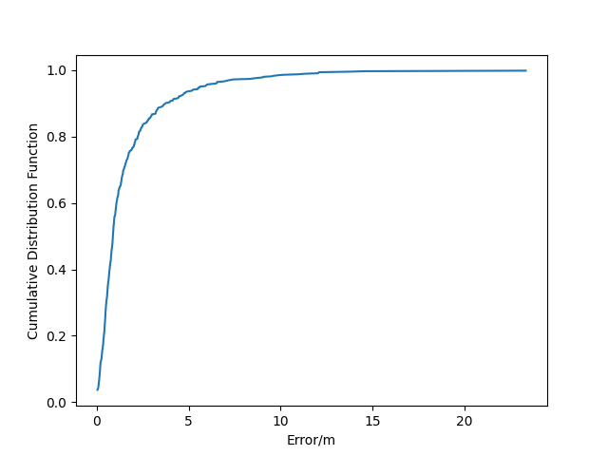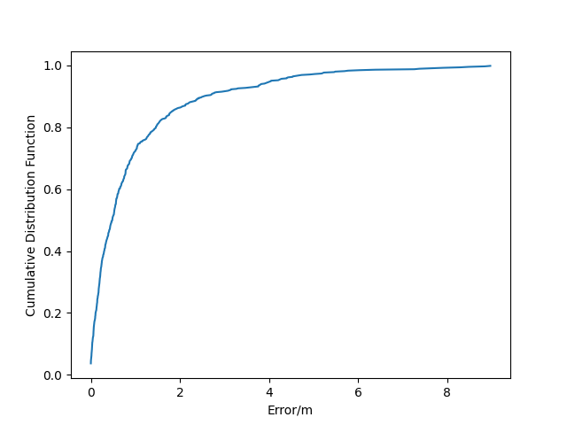
- Horizontal positioning error (b) Vertical positioning error
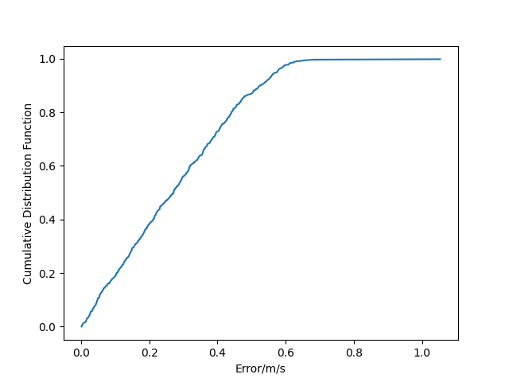
(c) Velocity error
Figure 5.4.2-1 CDF of RMa-AV scenarios without pulse signal (Antenna configuration A)
For the sensing without pulse signal, only the CP-OFDM with existing RS is used. For antenna configuration B, the CDF curves of position and velocity accuracy, missing detection probability and false alarm probability are provided based on evaluation results as below.
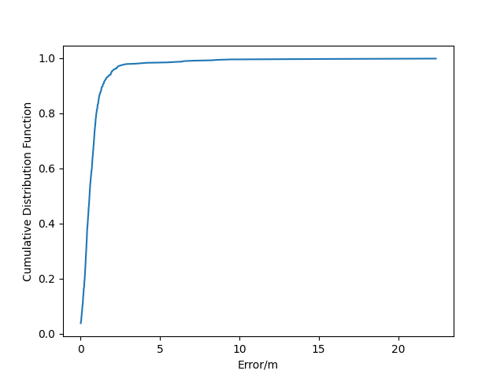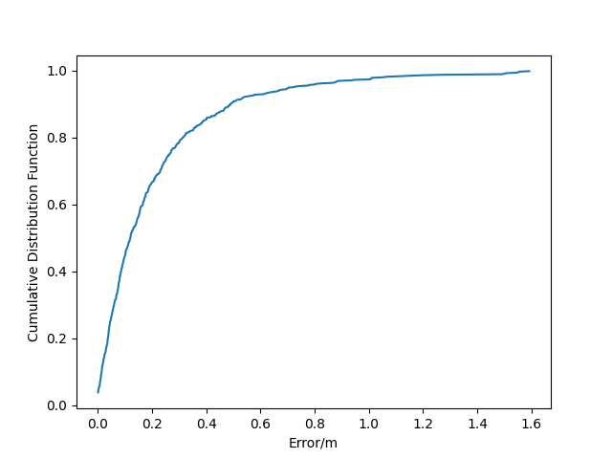
- Horizontal positioning error (b) Vertical positioning error
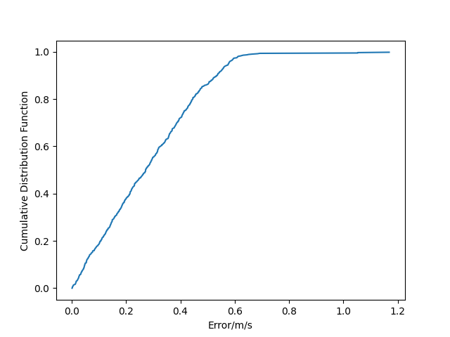
(c) Velocity error
Figure 5.4.2-2 CDF of RMa-AV scenarios without pulse signal (Antenna configuration B)
For the sensing without pulse signal, the CP-OFDM with both existing RS and pulse signal is used. For antenna configuration A, the CDF curves of position and velocity accuracy, missing detection probability and false alarm probability are provided based on evaluation results as below.
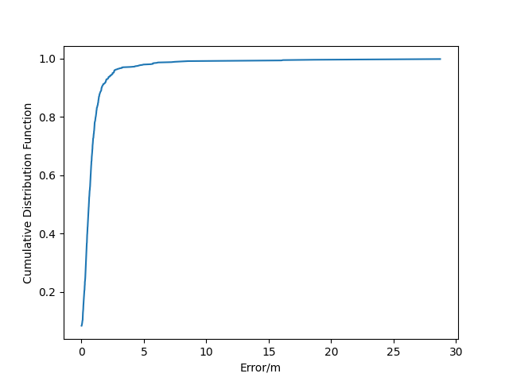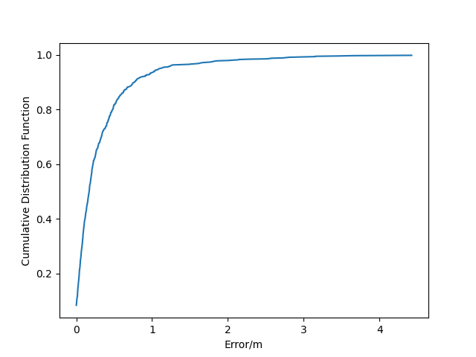
- Horizontal positioning error (b) Vertical positioning error
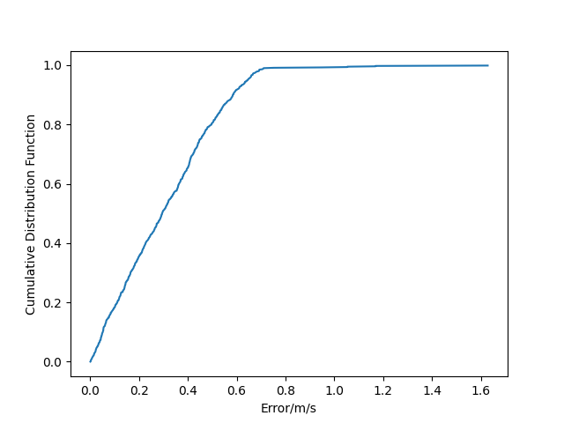
(c) Velocity error
Figure 5.4.2-3 CDF of RMa-AV scenarios without pulse signal (Antenna configuration A)
For the sensing without pulse signal, the CP-OFDM with both existing RS and pulse signal is used. For antenna configuration B, the CDF curves of position and velocity accuracy, missing detection probability and false alarm probability are provided based on evaluation results as below.
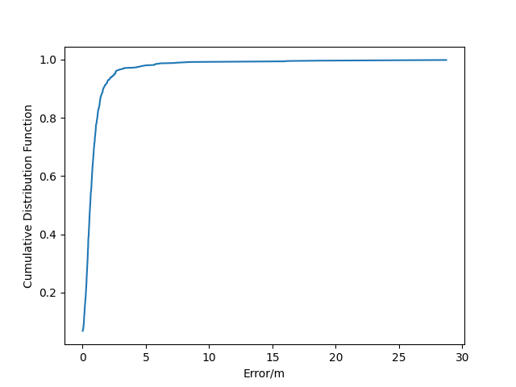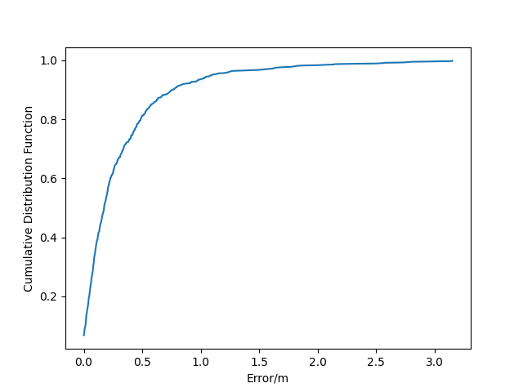
- Horizontal positioning error (b) Vertical positioning error
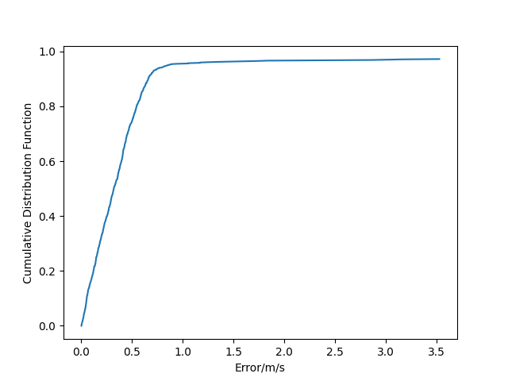
(c) Velocity error
Figure 5.4.2-4 CDF of RMa-AV scenarios with pulse signal (Antenna configuration B)
Based on evaluation results, The following performance comparison for antenna configuration A and B are shown in Table 5.4.2-2 and Table 5.4.2-3. For both antenna configurations, it is important to have pulse signal for aNB mono-static sensing
Table 5.4.2-2 Performance comparison of detection and positioning in RMA-AV (Antenna configuration A)
Evaluation method | Hor accuracy  @90% | Ver accuracy  @90% | Vel accuracy  @90% |  |  |  | Whether all performance objectives are met
CP-OFDM w/o pulse signal | 4.469m | 3.142m | 0.530m/s | 17.20% | 0% | 13.70% | No
CP-OFDM w/ pulse signal | 2.203m | 0.963m | 0.581m/s | 4.90% | 0% | 4.90% | Yes
Table 5.4.2-3 Performance comparison of detection and positioning in RMA-AV (Antenna configuration B)
Evaluation method | Hor accuracy  @90% | Ver accuracy  @90% | Vel accuracy  @90% |  |  |  | Whether all performance objectives are met
CP-OFDM w/o pulse signal | 2.580m | 0.543m | 0.535m/s | 16.40% | 0% | 13.80% | No
CP-OFDM w/ pulse signal | 2.163m | 0.996m | 0.617m/s | 3.80% | 0% | 4.60% | Yes

Moreover, another system system-level simulation of 4GHz urban grid vehicle TRP-UE bi-static sensing scenario is conducted to compare the performance of CSI-RS and pulse signal. Also as the evaluation assumptions in agenda 10.8.1 are not ready, the relating parameters are listed in Table 5.4.2-4.
Table 5.4.2-4 Evaluation assumptions of CSI-RS and pulse signal comparison
Parameters |  | Assumptions of CSI-RS | Assumptions of pulse signal
Scenario |  | Urban Grid
Sensing Tx/Rx operating simultaneously or not |  | TRP-UE bi-static  (Sensing Tx/Rx operating simultaneously)
Carrier frequency |  | 4GHz
Max BS Tx power |  | 37 dBm | 56 dBm
BS antenna configuration |  | Configuation : (M, N, P, Mg, Ng, Mp, Np): (8,8,2,1,1;4,8)  $\left(d_{H},d_{V}\right)$ = (0.5, 0.8)λ, +45°/-45° polarization
UE antenna configuration |  | Configuation: (M, N, P, Mg, Ng, Mp, Np): (2,2,2,1,1;2,2)  $\left(d_{H},d_{V}\right)$ = (0.5, 0.5)λ, +45°/-45° polarization
Number of targets per sector in the center site |  | N=4
Target vertical distribution |  | 1.6m
Waveform |  | CP-OFDM | Pulse signal generated by OFDM
System bandwidth |  | 100 MHz
Numerology |  | SCS = 30 kHz
CPI (ms) |  | 64
Period of CPI (ms) |  | 576
BS Layout |  | 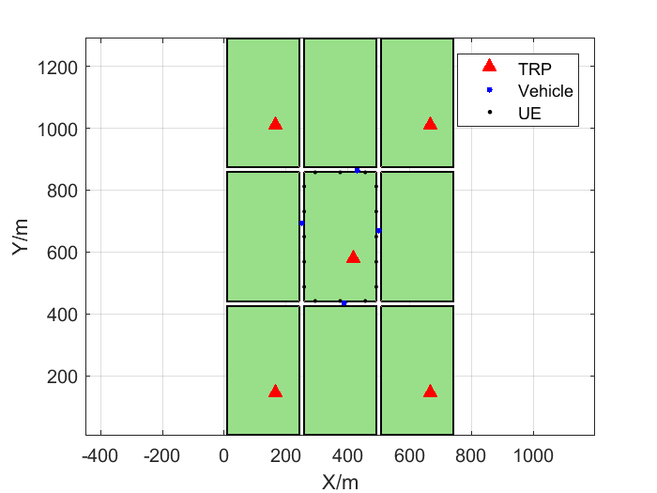  3 sectors with 30, 150, 270 degrees
Wrap-round |  | No wrap-round
EO type 2 |  | Not modeled
BS antenna height |  | 25 m
BS antenna radiation pattern |  | Table 9 in Report ITU-R M.2412
BS antenna mechanic tilt |  | 90° in GCS (pointing to horizontal direction)
BS antenna electrical tilt |  | Option 1: no electrical tilt
Polarized antenna model |  | Model-2 in clause 7.3.2 in TR 38.901
Antenna isolation |  | Not applied
Inter-site interference |  | Not modelled
Self-interference |  | X=0dB
Co-site inter-sector interference |  | Not modelled
Adjacent channel interference |  | Not modelled
BS receiver noise figure |  | 5 dB
Sensing target | Target type | Vehicle type 2 [TR37.885]  5m x 2m x 1.6m
 | 3D distribution | Dropping 4 targets randomly distributing in the center grid lanes  Horizontal plane: Uniformly distributed in each lane of the center grid  Vertical plane: 1.6m
 | Mobility | Horizontal speed: 60km/h  Vertical speed: 0km/h
 | Minimum BS-target 3D distance | Min distances based on min TRP/UE distances defined in TR37.885
 | Minimum target-target (3D) distance | 10 m
 | Outdoor/indoor proportion | 100% outdoor
 | LOS/NLOS | LOS
 | Orientation | Along the vehicle lanes
 | RCS model | Table 7.9.2.1-4(RCS model for vehicle with single scattering point)
gNB-target link |  | TRP-Vehicle link in Table 7.9.3-2 in TR 38.901, using Clause 6 in TR 37.885
UE-target link |  | Pedestrian type UE: Terrestrial UE-Vehicle link in Table 7.9.3-2 in TR 38.901, using V2P link in Clause 6 of TR 37.885
Concatenation of TX-target and target-RX links |  | Option 2 in Step 9 in section 7.9.4.1, TR 38.901
The power threshold for path dropping after concatenation for target channel |  | -40 dB
Method for association of detected object(s) and true targets(s) |  | Based on each true target, the nearest detected object within a distance of 10 meters from the true target is regarded as an estimation of true target; otherwise, it is considered as a false alarm.
Low power cluster |  | Not modeled
Clutter mobility |  | Not modeled
TRP selection method |  | A target is present in the channel of multiple TRPs  Large scale channels and small scale channel between each target and all adjacent STX/SRXs are generated accordingly. For each sensing target, one typical STX/SRX with highest received power after whole target channel is selected.  For each selected STX/SRX, all targets in its and adjacent serving cells could be measured as selected targets or interference.
Tx beam information  (different from baseline) |  | 4 vertical beams and 2 horizontal beams  For each beam, comb 4 in frequency domain and comb 7 in time domain | 4 vertical beams and 2 horizontal beams  For each beam, comb 1 in frequency domain and comb 7 for each 2 pulse signal beam in time domain
T/F RE mapping of sensing RS, assumed TDD UL/DL configuration if applicable |  | In each CPI of 128 slots, 4 vertical beams are used, and using 2 periods of CPI to scan all beams. Each beam would occupy n-th and n+7-th (n=0,1,...3) symbol with comb-4 in each slot of CPI. | In each CPI of 128 slots, 4 beams are scanned, and using 2 periods of CPI to scan all beams of pulse signal. In each slot, every 2 beams would occupy n-th and n+7-th (n=4,5) symbol with comb-1 in each slot of CPI.
 |  | For CP-OFDM and pulse signal generated with OFDM without tracking knowledge, the sensing resource ratio is calculated by
Sensing signal/data processing method |  | RD-profile: 2D-DFT  Peak detection on RD-profile: CFAR  Angle estimation: Maximum likelihood (ML) estimation
Cooperative sensing |  | The STX/SRX selection is based on measured RD profile of each STX/SRX, and then only one best STX/SRX is decided to measure one typical sensing target.
Vehicle motion model |  | No
For CSI-RS, the density is set to . And in this condition, the CDF curves of position and velocity accuracy, missing detection probability and false alarm probability are provided based on evaluation results as below.
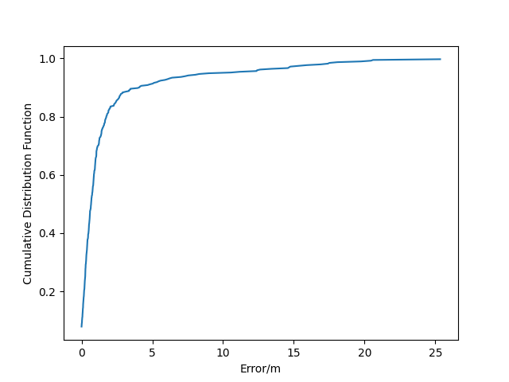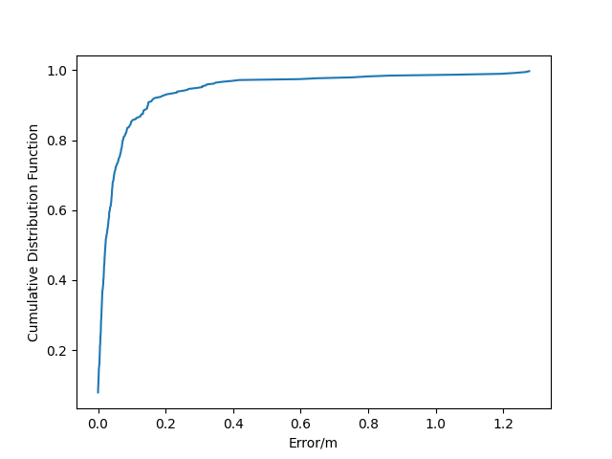
(a) Horizontal positioning error (b) Vertical positioning error
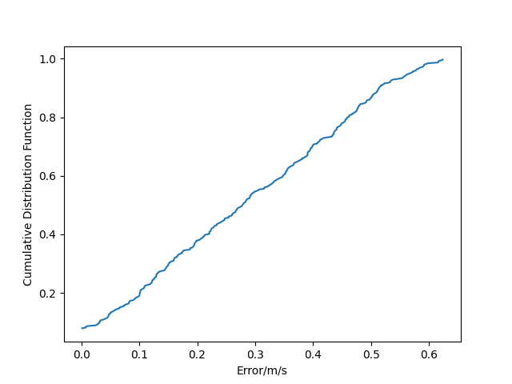
(c) Velocity error
Figure 5.4.2-5 CDF of vehicle in urban grid scenario with CSI-RS (TRP-UE bi-static)
Table 5.4.2-5 Performance comparison of detection and positioning of vehicle in urban grid(TRP-UE bi-static)
Sensing RS | Hor accuracy  @90% | Ver accuracy  @90% | Vel accuracy  @90% |  |  |  | Whether all performance objectives are met
CSI-RS | 3.967m | 0.146m | 0.513m/s | 9.25% | 0% | 7.87% | No

For pulse signal, the CDF curves of position and velocity accuracy, missing detection probability and false alarm probability are provided based on evaluation results as below.
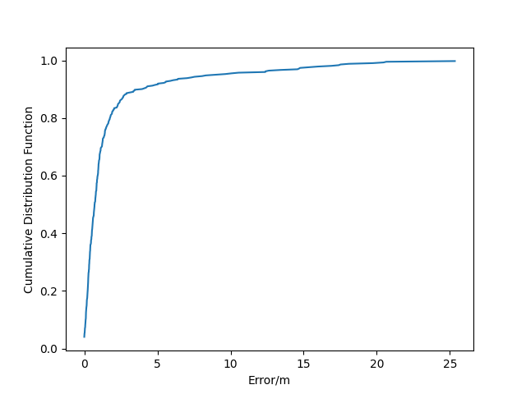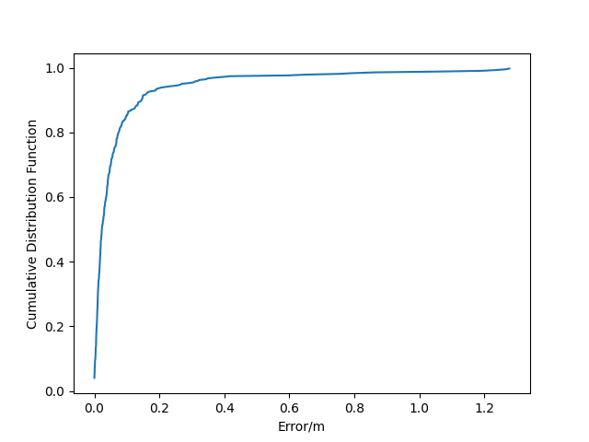
(a) Horizontal positioning error (b) Vertical positioning error
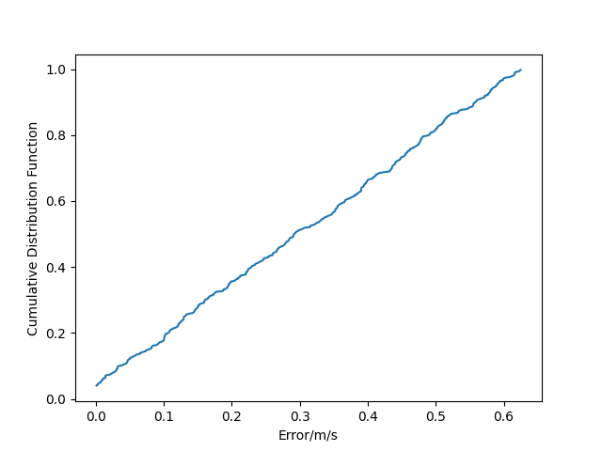
(c) Velocity error
Figure 5.4.2-6 CDF of vehicle in urban grid scenario with pulse signal (TRP-UE bi-static)
Table 5.4.2-6 Performance comparison of detection and positioning of vehicle in urban grid(TRP-UE bi-static)
Sensing RS | Hor accuracy  @90% | Ver accuracy  @90% | Vel accuracy  @90% |  |  |  | Whether all performance objectives are met
Pulse signal | 3.451m | 0.143m | 0.557m/s | 4,50% | 0% | 4.26% | Yes
Observation 9: For TRP-UE bi-static sensing, pulse signal can achieve better sensing performance than CSI-RS by assuming CSI-RS is shared with TRP mono-static sensing.

5.4.3 Sensing Assisted Communication
Sensing assisting beam management can be typically applied to UMa and Urban Grid scenarios regarding vehicles as sensing target in TRP-UE bi-static sesning mode. Table 5.4.3-1 provides the detailed simulation assumption for sensing assisting beam management in Urban Grid scenario.

Table 5.4.3-1 Simulation assumption for sensing assisting beam management in Urban Grid scenario
Parameters |  | Values
ISAC use case |  | ISAC-Automotive
Cell Layout |  | ISD = 500m, BS height=25m, the layout is defined as below:
BS antenna radiation pattern |  | Table 9 in Report ITU-R M.2412
BS antenna mechanic tilt |  | 90° in GCS (pointing to horizontal direction)
BS antenna electrical tilt |  | no electrical tilt
BS antenna configuration |  | (M, N, P, Mg, Ng, Mp, Np) = (16, 16, 2, 1, 1; 4, 16)  $\left(d_{H},d_{V}\right)$ = (0.5, 0.5)λ, +45°/-45° polarization
Sensing target size  (Length x Width x Height) |  | Vehicle type 2 [TR37.885]  5m x 2m x 1.6m
Sensing target | Sensing target distribution | Option B:  Dropping N sensing targets randomly distributing in the center grid lanes. e.g. N=1
 | Sensing target mobility | 60 km/h along the road side
 | Minimum BS-target 3D distance | Min distances based on min TRP/UE distances defined in TR37.885
 | Minimum target-target (3D) distance | Option 1: At least larger than the physical size of a sensing target  Option 2: Fixed value, 10 m.
 | Outdoor/indoor proportion | 100% outdoor
 | Orientation | Along the vehicle lanes
 | RCS model | Table 7.9.2.1-4(RCS model for vehicle with single scattering point)
gNB-target link |  | TRP-Vehicle link in Table 7.9.3-2 in TR 38.901, using Clause 6 in TR 37.885
UE-target link |  | Pedestrian type UE: Terrestrial UE-Vehicle link in Table 7.9.3-2 in TR 38.901, using V2P link in Clause 6 of TR 37.885
Concatenation of TX-target and target-RX links |  | Option 2 in Step 9 in section 7.9.4.1, TR 38.901
The power threshold for path dropping after concatenation for target channel |  | -40 dB
Low power cluster |  | Not modeled
UE height |  | 1.5m for pedestrian type UE
UE distribution |  | - Pedestrian type UT, the dropping using equally spaced along the sidewalk with a fixed inter-pedestrian X m dropped per TR 37.885  - Total number of pedestrian UEs is 16 in the centre grid.  - Pedestrian UE is in the middle of the sidewalk  - The inter-pedestrian UE distance (m) (i.e., X) is calculated by ‘A/(16*N)’, where ‘A’ is the total length of sidewalk where the pedestrian UEs are dropped under the assumption of ‘N’ road grids (i.e., ‘{(250m – 17m) + (433m – 17m)} * 2 * N’).  - N=1;
UE antenna configuration |  | (M, N, P, Mg, Ng, Mp, Np) = (2, 2, 1, 1, 1; 2, 2)  $\left(d_{H},d_{V}\right)$ = (0.5, 0.5)λ, single polarization
UE mobility |  | Not consider for ISAC-Automotive in urban grid
RS type |  | Pulse RS, CSI-RS
In order to evaluated the performance of sensing assisting beam management, the beam management performance of pulse RS used as RS is compared with the beam management performance of CSI-RS, where the beam management performance of CSI-RS is used as the benchmark. In the following, three metrics regarding sensing assisting beam management are defined:
- Accurate ratio of communication beam selection
The receiver measures RSRPs of multiple beams with pulse RS as sensing RS. N beams corresponding to N maximum sensing RSRPs are selected as estimated communication beams, where N can be 1, 2, 3 or 4. If the N estimated communication beams include the true communication beam, it can be regarded as one accurate communication beam selection or successful sensing assisting beam management. Through counting multiple drops, the accurate ratio of communication beam selection can be obtained. Specifically, the true communication beam can be gotten by measuring maximum RSRP with CSI-RS as communication RS.
- CDF of RSRP gap of estimated communication beams
The gap of RSRPs between the estimated best communication beam and the estimated second best communication beam can be calculated. Similarly, the gap of RSRPs between the true best communication beam and the true second best communication beam can be calculated. Then, the CDF of RSRP gap of estimated beams can be compared with that of RSRP gap of true beams.
In the section, the simulation results regarding the two defined metrics for sensing assisting beam management are provided. Table 5.4.3-2 show the accurate ratio of communication beam selection, which show the pulse signal can be used for beam selection. Figure 5.4.3-1 provide the CDF curves of RSRP of best beam using pulse RS and CSI-RS. In practice, the power loss due to pulse can be compensated by the following factors:
- Sensing signal repetitions. The sensing signal is usually transmitted with some repetitions.
- Pulse signal power boosting. Many hardware metrics, e.g., power source driving capability, work for average power, and it is possible for the pulse signal to boost a little bit.
Even without the compensation, pulse signal can still be used for the UE with relatively good channel condition, which increases the spectrum utilization and is also beneficial to both the UE and aNB Figure 5.4.3-2 shows the CDF curves of RSRP gap between top-2 beams using pulse RS and CSI-RS, which demonstrates the similar effect on best beam caused by the second best beam using pulse RS and CSI-RS.
Observation 10: Pulse signal can be used for communication beam selection with an accurate ratio ≥ 94%, which includes the cases that the Top-2 beams have very close RSRP.
Table 5.4.3-2 Accurate ratio of communication beam selection
Value of N | Accurate ratio of communication beam selection
N=1 | 94.00%
N=2 | 94.00%
N=3 | 97.05%
N=4 | 97.39%
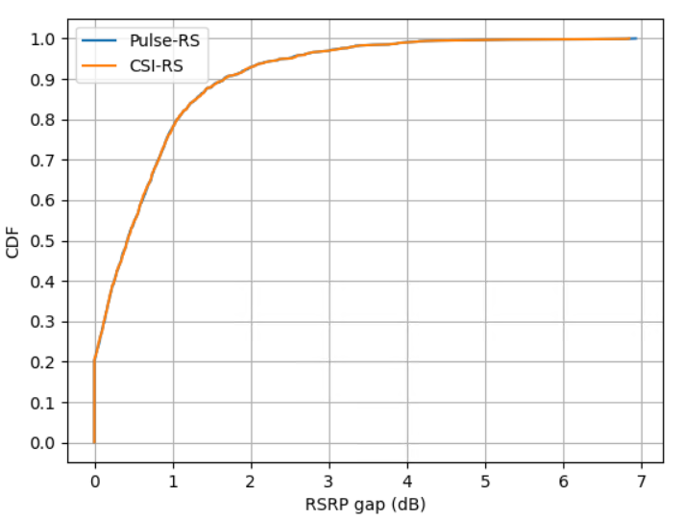
Figure 5.4.3-1 CDF curves of RSRP gap between top-2 beams using pulse RS and CSI-RS

Conclusion
In conclusion, we have following observations and proposals for 6G ISAC RS, waveform and frame structure:
Proposal 1: For 6GR sensing waveform design, it should be first clarified that sensing signal is an RS.
Proposal 2: 6GR sensing RS should be compatible with communication hardware.
Observation 1: For 6G ISAC, a coverage of larger than ISD, e.g., 1732 m in RMa, is needed due to blind area of base station, and hence a large transmission power is needed.
Observation 2: The self-interference and saturation issue greatly limit the transmission power of the communication waveform in mono-static sensing.
Observation 3: For Los probability, aNB mono-static sensing is better than aNB bi-static sensing, and aNB bi-static sensing is better that aNB-UE bi-static sensing.
Proposal 3: Study the following candidates of sensing RS/sequence for CP-OFDM, considering the potential sensing RS sharing among different sensing modes
- Pulse-like RS
- FMCW-like RS
- RS in guard band
- Sequence enhancement for Gold and ZC
- The combinations of the candidates, e.g., FMCW-based Pulse RS
Observation 4: PAPR/CM of ZC sequences with different root indices have very large difference, e.g., ΔCM > 3dB.
Observation 5: NLFM obtain time-domain constant modulus at sampling points as well as frequency-domain bell-like window shape.
Proposal 5: Considering at least the following aspects for sensing signal enhancements:
- Self-interference mitigation at least for sensing signal sharing
- PAPR reduction
- Sidelobe reduction capability and flexibility
Proposal 6: For 6GR ISAC, study Pulse-like RS based on CP-OFDM waveform considering the following beneficial characteristics
- Large sensing coverage for 6G ISAC
- Support full duplex without hardware modification
- Overhead reduction for multi-static sensing
- Measurement utilization potentially for sensing assisting communication
- Equivalent to a long CP/GP length
Observation 6: With regards to specifying waveform for TRP mono-static sensing and TRP bi-static sensing, there are two interpretations:
- Alt.1 TRP needs to exchange sensing RS configuration with SF or another TRP;
- Alt.2 The sensing RS design for TRP-UE or UE-TRP bi-static sensing should consider RS sharing with TRP mono-static sensing and TRP bi-static sensing
- Note: For Alt.2, there may not be an extra spec impact on top of TRP-UE or UE-TRP bi-static sensing
Proposal 7: Avoid discussion of waveform/RS per sensing mode, and strive to design a unified RS/waveform scheme for all sensing modes, i.e. the sensing RS may be shared for multi-static sensing modes.
Proposal 8: Study pulse RS sequence using at least the following generation methods:
- Time-domain generation
- Frequency-domain generation
- Other methods are not precluded
Observation 7: For UE and other aNB nodes, the pulse sensing signal can be received and processed as an RS with a dedicated sequence in the frequency domain.
Proposal 9: When needed, CP length should be equivalently extended without changing frame structure, e.g., frequency-domain comb, time-domain repetitions with continuous phase.
Proposal 10: Study NR RIM-RS like design for 6GR sensing, i.e. considering single FFT operation for one RS resource with multiple OFDM symbols.
Proposal 11: Study the sensing net gain to evaluate the overall/final performance of sensing signal using the following formula.
- Sensing Net Gain [dB] = TX power gain relative to the reference – SNR degradation relative to the reference
- TX power gain is determined by the waveform analysis
- SNR degradation is determined by
  - Option 1: Theoretical SNR degradation by waveform analysis
  - Option 2: Simulated SNR degradation by LLS/SLS
Proposal 12: At least the following waveform metrics should be considered for 6G sensing signal.
- Period auto-correlation
- PAPR issue
- Self-interference resilience
- Maximum unambiguous range
- Reusing for communication
Proposal 13: For SNR degradation/gap calculation, the first priority is to only use LLS, and if LLS has no consensus, SLS should be used.
Observation 8: For time-domain pulse and frequency-domain pulse, the waveform characteristics, including PAPR/CM and auto-correlation (mainlobe and sidelobe), are very close to each other.
Observation 9: For TRP-UE bi-static sensing, pulse signal can achieve better sensing performance than CSI-RS by assuming CSI-RS is shared with TRP mono-static sensing.
Observation 10: Pulse signal can be used for communication beam selection with an accurate ratio ≥ 94%, which includes the cases that the Top-2 beams have very close RSRP.

References
- RP-251881, New SID: Study on 6G Radio, NTT DOCOMO (Moderator)

